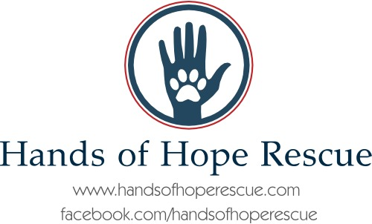
OWNER SURRENDER FORM
LOCATED IN KANSAS AND MISSOURI

NAME OF OWNER: ___________________________________
ADDRESS/CITY/STATE: ________________________________
EMAIL ADDRESS: ____________________________________
PHONE NUMBER: ____________________________________
REASON FOR SURRENDER: _____________________________
___________________________________________________
___________________________________________________
NAME OF DOG:________________________ AGE: _________
BREED: ______________________ MALE/FEMALE?________
IS THE DOG SPAYED/NEUTERED? ________________________
IS THE DOG CURRENT ON VACCINATIONS? ________________
RECORDS FOR VACCINATIONS, ETC. INCLUDED? YES__ NO __
NAME OF VET, LOCATION AND NUMBER: _________________
___________________________________________________
IS DOG MICROCHIPPED? IF YES WHAT IS # OF CHIP AND COMPANY ____________________________________________________ ____________________________________________________
IS DOG HOUSE TRAINED? ______________________________
IS DOG CRATE TRAINED? _______________________________
DOES DOG GET ALONG WITH OTHER MALE AND FEMALE DOGS & WHAT SIZES HAS DOG BEEN EXPOSED TO: _________________
____________________________________________________
HAS THIS DOG EVER SHOWN AGGRESSION OR ATTACKED ANOTHER DOG AND IF SO PLEASE EXPLAIN: _________________________
_____________________________________________________
IS THIS DOG GOOD WITH CHILDREN? ______________________
HAS THIS DOG EVER SHOWN SIGNS OF AGGRESSION OR BITTEN A CHILD OR ADULT? IF SO, PLEASE EXPLAIN:
_____________________________________________________
_________________________________________________
IT IS IMPERATIVE THAT WE KNOW ANY ISSUES YOUR DOG MAY HAVE IN ORDER TO PLACE HIM/HER. PLEASE WRITE ANY BEHAVIOR ISSUES, FOOD AGGRESSION, TREAT/TOY AGGRESSION ANYTHING ELSE THAT WILL BE HELPFUL IN TRAINING IN ORDER TO HELP THIS DOG. __________________________________________________
__________________________________________________
__________________________________________________
PLEASE LIST ANY TRAINING THIS DOG HAS HAD OR COMMANDS/TRICKS THIS DOG KNOWS: ________________
__________________________________________________

I, _____________________________, RELINQUISH OWNERSHIP AND RESPONSIBILITY OF ________________, TO HANDS OF HOPE RESCUE FOR THE PURPOSE OF REHOMING OR FINDING A SUITABLE RESCUE FOR SAID DOG. I HAVE COMPLETED THIS FORM AND VERIFY ALL STATEMENTS MADE TO BE TRUE AND ACCURATE TO THE BEST OF MY KNOWLEDGE.
Signature______________________________ DATE: _______________
(MUST HAVE HAND SIGNED AND DATED. WILL NOT ACCEPT IF TYPED)

